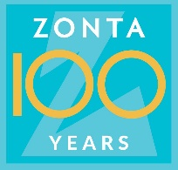 June 10, 2019
SOCIAL MEDIA CAMPAIGN, THEME OF THE MONTH FOR SEPTEMBER:
ZONTA AS AN ACTIVE THIRD SECTOR ORGANIZATION - NOW AND IN THE FUTURE

During the centennial anniversary year 2019, District 20 is organizing a social media campaign with the objective to discuss important topics of Zonta International, share past Zonta activities and why these themes continue to be important. The campaign has a defined theme per each month.

Attached you will find the social media message templates for September 2019, the plan for the Day of Charity (September 5, 2019) and the background material for the theme of the month. Clubs and members can utilize these materials when planning and executing their own social media communications.

Social medial messages of September are providing information and increasing awareness of international, district and club examples of how Zontians are active in various ways in what is known as the ‘third sector’ and how they are working to support the well-being and create opportunities for girls and women with various co-operation partners.

- Social Media Messages

For September, several social media messages have been prepared. At least two messages per week will be sent out in September as follows
- week 26 Mon, Sep 2nd and Thu, Sep 5th
- week 37 Mon, Sep 9th and Thu, Sep 12th
- week 38 Mon, Sep 16th and Thu, Sep 19th
- week 39 Mon, Sep 23rd and Thu, Sep 26th.

The social medial messages introduce facts about the significance of our voluntary activities and about their necessity also today and encourage to join and donate to various campaigns. Social media messages are supplemented with links to the examples of needs, work done, results and photos related to the September theme.

The Clubs and each Zontian need to be active in their own social medial channels. It is important that the clubs co-operate with other clubs in their Area, utilize the local opportunities and share encouraging examples of the women and girls in their area. Clubs’ should introduce also their own local projects and activities related to the theme. Additionally, we can encourage our local and area co-operation partners through giving credit for their work.

The social media campaign is utilizing different channels in a versatile manner:
- Instagram and YouTube to reach the younger audience
- Facebook reaches also elder audience
- Twitter and LinkedIn to reach decision-makers
- Radio and TV co-operation to reach the general public

- ZONTA ACTIVITIES ON THE INTERNATIONAL DAY OF CHARITY, September 5, 2019

ZONTA EMPOWERING GIRLS AND WOMEN – ZONTA AS AN IMPORTANT THIRD SECTOR ORGANIZATION

Zonta International serves and influences on the third sector. Zontians have been advocates for girls and women already for 100 years. This charity and voluntary work will continue to be relevant also in the future.

On the Day of Charity, September 5, 2019, the clubs by themselves or with each other, or as Areas will organize events to increase awareness of Zonta activities, to raise funds for the programs and to find further co-operation partners.

Events are to be organized in the most suitable locations locally, for example, on the market places, shops or in other locations where we can reach as many as possible. In these events, we will be distributing Zonta wristbands and information on Zonta activities plus raising funds for the projects preferred by the club for example for the ZAU campaign (Zonta advances U).

Printed wristbands are available for order since June 24, 2019, from Zonta club Helsinki IV for 15 euro/100 pcs.
The orders can be sent to Helena Miller via e-mail helena.miller@themillers.fi, stating the nr of packages with 100 pcs each, the club name, the name of the orderer, address and phone number. The order is paid to the Zonta club Helsinki IV account FI3612283000022218, with invoice message ‘wristbands/the name of the club placing the order’. After the order and payment have been received, the wristbands will be mailed to the address informed in the order.

When introducing Zonta activities, the clubs can use the recently published brochure of District 20 and the information on our web pages. It is important to increase awareness of the local activities and share information on which international programs that club is contributing to and which own projects the club has.

For raising the funds Zonta International District 20 has the fundraising permit RA/2018/394 issued by the National Police Board and valid from April 13, 2018 to April 14, 2020 within Finland, excluding Aland. The permit covers all current Zonta national and international programs. The clubs can decide for which purpose they will raise funds. Fundraising may take place with collection boxes or otherwise, but the permit must always be visible. Also searching for collaboration partners to the Club and Area projects can be done in the context of the Day of Charity activities.

For further information, please contact
Sirkka-Liisa Kärki, sirkkaliisa.karki@gmail.com, 0500549586
Tarja Larmasuo, tarja.larmasuo@kolumbus.fi ,0405688233
Helena Miller, helena.miller@themillers.fi, 0400615588

SEPTEMBER SOCIAL MEDIAL MESSAGES – Zonta as a third sector organization

Message 1, broadcast on Monday, September 2, 2019

Did you know that Zonta International has been empowering girls and women for already 100 years?
Currently we focus on ending child marriages and discrimination by supporting Syrian refugees in Jordan and improving girls’ opportunities for education in Madagascar.
#zonta100 @ZontaDistrict20
https://youtu.be/OT027qLAdxg

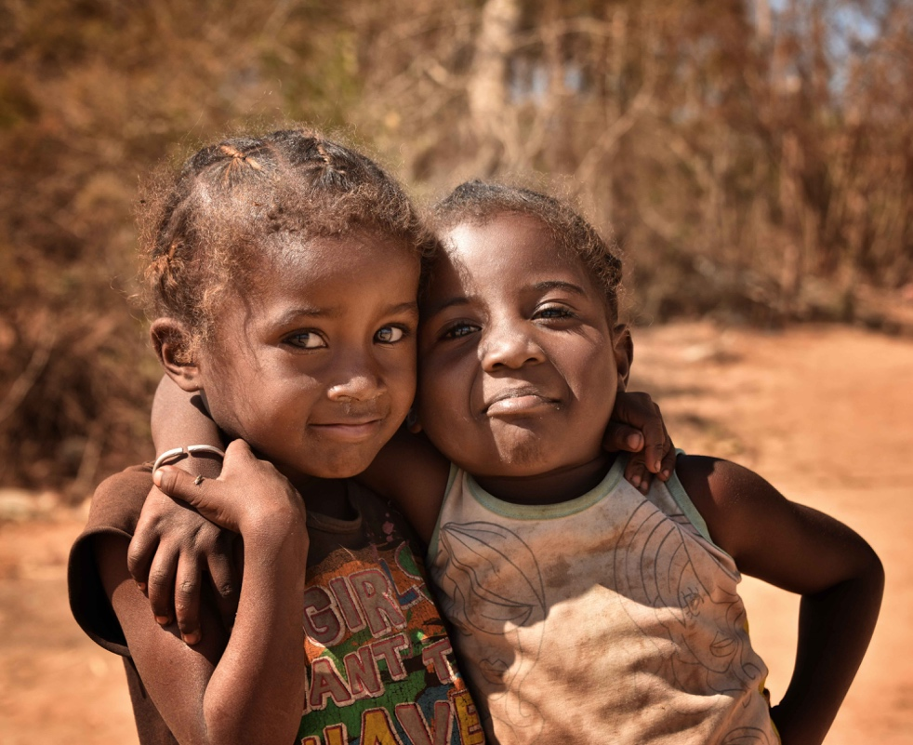
Children in Madagascar

The following text from the background materials can be linked to this message:

Zonta activities in the past and in the future

Since 1923, Zonta International has donated over 40 million US dollars to improve the girls and women’s education, health care, economic opportunities and living conditions
The programs and donations through the Zonta International Foundation improve women’s lives, their children’s lives and those communities where they live and work. This contributes to the equal rights of the women and girls’ worldwide.

Zonta International has a General Consultative Status since 1969 in the ECOSOC (UN Economic and Social Council), ILO (International Labour Organization) and Unesco. The organization has a General Consultative Status in the forum of Non-Governmental Organization working in New York, Geneva, Vienna and Paris, and negotiating member status in Council of Europe since 1983. The key co-operation partners of Zonta International are UNICEF, UNPFA and UNIFEM.
https://foundation.zonta.org/Portals/0/Zonta/Global%20Impact/ISPHistory.pdf

Message 2, broadcast on Monday, September 2, 2019

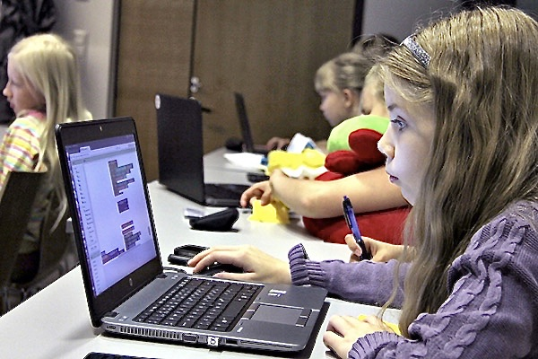

Do you know Zonta programs in Finland? ZAU (Zonta Advances U) encourages 10 – 12 years old girls to study mathematics and natural sciences. Helvi Sipilä fund continues to support a mother-child clinic in Ruanda to prevent HIV infections.
zau.fi @zontadistrict20

https://foundation.zonta.org/Our-Programs/International-Service-Program

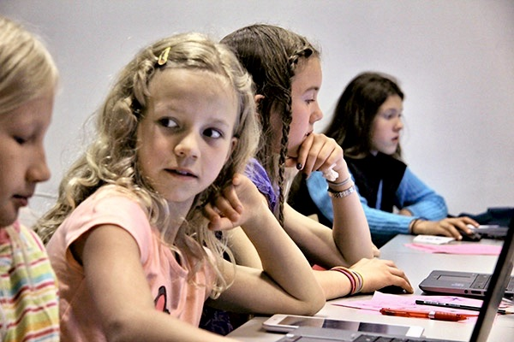

Message 3, broadcast on Thursday, September 5, 2019

Today, September 5th, it is the Day of Charity! Zontians are campaigning today to collect funds to help children and women, for example in the ZAU project
#zonta100 @ZontaDistrict20

. 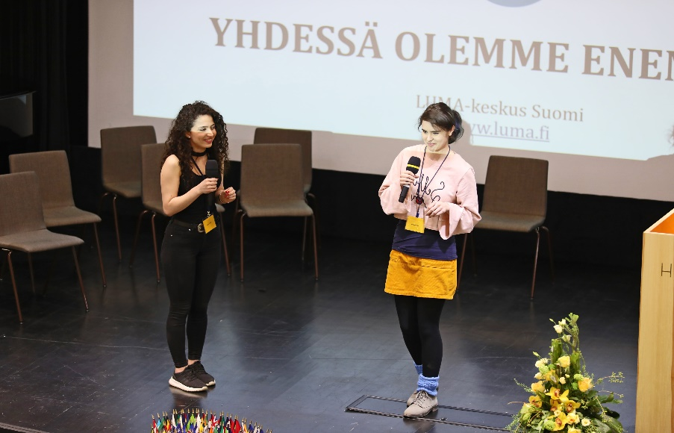

Message 4, broadcast on Monday, September 9, 2019

No violence and oppression in women and children’s lives! As regards the women experiencing violence, Finland scores highest in the European statistics.
Become a supporter of Zonta says NO and ensure together with Zontians that the girls will have a safe childhood. www.ZontaSaysNO.com #zonta100 @ZontaDistrict20
https://foundation.zonta.org/Our-Programs/ZISVAW-Program

The following text from the background materials can be linked to this message:

Partners are important for Zonta

Co-operation partners are important for Zonta in multiple ways. With our partners, both the District and Clubs are executing projects, increasing awareness and impacting decision-making. Most of the partners are other organizations. Locally important partners are municipalities or cities and local enterprises supporting the fund raising. The support to local activities is important for advancing the objectives of the whole organization.

Several politicians, artists, authors have joined as speakers in our charity events, but they also work as active Zontians. Through decades several umbrella organizations have been co-operating with us in campaigns and otherwise, for example, women’s organizations, Martha organization, The Federation of Mother and Child Homes and Shelters, Mannerheim League for Child Welfare, Finnish Red Cross. Other important partners, operating nationally, have been Girls’ Houses, Victim Support and prison volunteer work. In addition, we have also been co-operating with the Finnish Association for the Welfare of Older People in Ystäväpiiri (group of friends) activities.

For advocacy, the co-operation is crucial, and we are working side by side with the above-mentioned central organizations and similar associations. We would wish for more awareness of Zonta organization in Finland so that the important work of 100 years would become more visible.
Future co-operation partners could include international organizations like Solidarity Foundation.

Message 5, broadcast on Thursday, September 12, 2019

Do you know Zonta scholarships and awards? Several Finnish women have already received a Zonta Scholarship from Lisa Andström fund, Young Women in Public Affairs (YWPA) award for social volunteer activities or Jane Klausman scholarship for higher business education.
#zonta100 @ZontaDistrict20

https://foundation.zonta.org/Our-Programs/Educational-Programs/Young-Women-in-Public-Affairs-Award
https://foundation.zonta.org/Our-Programs/Educational-Programs/Jane-M-Klausman-Women-in-Business-Scholarship
https://foundation.zonta.org/Media-News/News/materials-for-the-2019-women-in-technology-scholarship-now-available
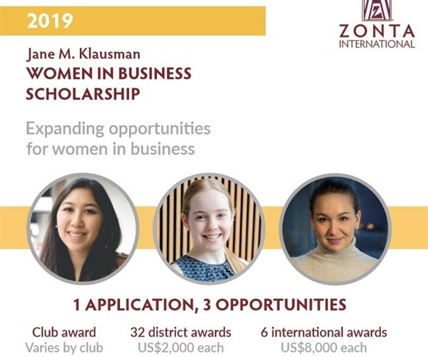

Message 6, broadcast on Thursday, September 12, 2019

Do you know Zonta educational programs? The most significant one is the Amelia Earhart Fellowship of 10,000 USD which is intended for promising scientists pursuing doctoral degrees in aviation and space research. This fellowship has been granted so far for seven women in Zonta District 20 i.e. Finland and Estonia.
#zonta100 @ZontaDistrict20
https://foundation.zonta.org/Our-Programs/Educational-Programs/Amelia-Earhart-Fellowship

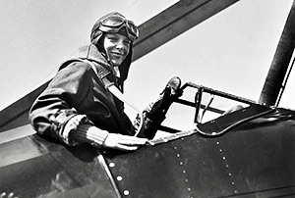

Message 7, broadcast on Monday, September 16, 2019

Join to support the international Zonta programs! Zonta Says NO campaign is driving to end child marriages. Eid bi Eid campaign is supporting Syrian refugee women in Jordan to improve their and their children’s well-being together with the local women.
#zonta100 @ZontaDistrict20

https://foundation.zonta.org/Our-Programs/International-Service-Program

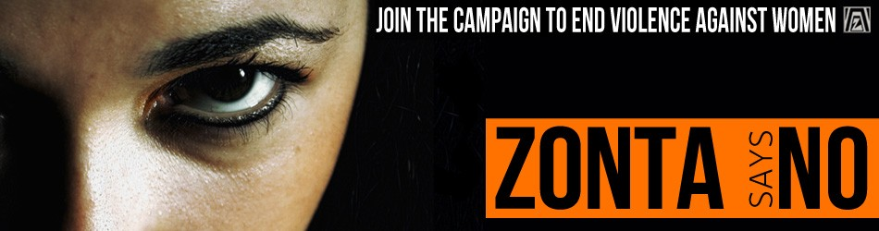

Message 8, broadcast on Thursday, September 19, 2019

Welcome to join the Zonta International! Zonta campaigns and donations improve women and children’s lives, education, health care, economic opportunities and living conditions. As a Zontian, you can leave a good mark on the world.
#zonta100 @ZontaDistrict20

The following text from the background materials can be linked to this message:

Zonta clubs are the most important functional unit of the organization. The clubs also play a central role in service activities. Each club has, according to the rules, their own service committee for planning and implementing local service activities. Examples of the club service activities can be found from the web pages. The club service projects include supporting women’s shelters, visiting elderly care homes, providing activities for the disabled and supporting immigrants’ studies of Finnish language and culture. The clubs execute their projects together with national and local co-operation partners.

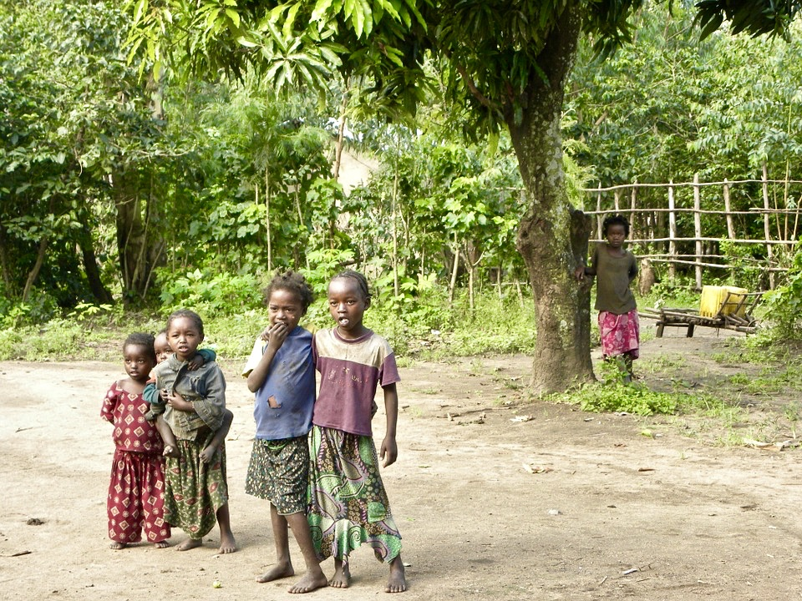
Message 9, broadcast on Monday, September 23, 2019

Zonta International contributes, initiates and implements with their partners both national and global programs, for example, helping those living under the threat of violence, immigrant women, lonely elderly people and those under the threat of social exclusion.
#zonta100 @ZontaDistrict20

https://foundation.zonta.org/Portals/0/Zonta/Global%20Impact/ISPHistory.pdf

Message 10, broadcast on Monday, September 23, 2019

Zonta clubs are also planning and executing local projects together with their partners e.g. visiting elderly care homes, supporting women’s shelters, providing activities for the disabled, and enabling immigrants’ studies of the Finnish language.
#zonta100 @zontadistrict20

Message 11, broadcast on Thursday, September 26, 2019

100-year-old Zonta International continues to defend girls and women’s rights also in the future. Zontians drive decreasing of discrimination and promote equal rights.
www.zau.fi #zonta100 @ZontaDistrict20

< Add Paula Risikko interview video here>

Paula Risikko is a Doctor of Science (Health Care) and a Finnish Politician, who has served as Minister of Social Services and Minister of Transport and Local Government.

- Twitter: @paularisikko #zonta100 @zontadistrict20 (so that the tweet will be visible also for Paula’s twitter followers)
- Instagram and Facebook: #paularisikko #zonta100 #zontadistrict20

The following text from the background materials can be linked to this message:

Zonta and the future of the third sector

The third sector, charity work and service programs are desperately needed – in the future even more, and the role as a lobbyist and influencer will be emphasized. When multiple discrimination is increasing, an intersectional viewpoint will be required.

Multiple discrimination refers to a situation where one person is being discriminated for several reasons, for instance for gender, native language, ethnicity or sexual orientation. When talking about girls and women’s rights, it is good to notice that all girls and women are not in an equal position – where one hits the glass ceiling only due to her gender, the other may be marginalized for other reasons at the same time. This phenomenon is called ‘intersectionality’. The intersectionality originates in 1980’s when the US scholar Kimberlé Williams Crenshaw presented a case of General Motors factory where black female workers were facing intersectional discrimination at their work place due to their ethnicity and gender, which was different from the discrimination of the black men or white women.

How to support girls with immigrant background to find a summer job in a country where jobs are often found through the networks of parents and relatives?
How to enable the motherhood and employment of disabled women in a society where both the day care centers and work places are often in inaccessible spaces and the taxi service for disabled is not allowed to go via the day care centers while back from work?

BACKGROUND MATERIAL FOR THE SEPTEMBER THEME

ZONTA AS AN ACTIVE THIRD SECTOR ORGANIZATION - NOW AND IN THE FUTURE

- VOLUNTARY AND CHARITY WORK IS NEEDED

- What is charity work, what is service, what it has been, what it is now, what it will be in the future
  - Micro loan projects
  - Emphasize the club projects
- Zonta activities locally and nationally – Zonta service programs and impact in the society, challenges of the future
- Finnish and Estonian women in a vulnerable position, bring up their needs, the needs of women of different ages
- What has been done by Zonta International and with whom, what in the past, what in the future
- What has been done within the District, in the Clubs, with whom, what in the past, what in the future

Zonta International is an international women’s organization, especially supporting the improvement of women and girls’ lives worldwide. Finnish Zonta campaigns also support Finnish causes.
International service programs: https://foundation.zonta.org/Our-Programs/International-Service-Program
International scholarships and awards:
https://foundation.zonta.org/Our-Programs/Educational-Programs/Amelia-Earhart-Fellowship
https://foundation.zonta.org/Our-Programs/Educational-Programs/Jane-M-Klausman-Women-in-Business-Scholarship
https://foundation.zonta.org/Media-News/News/materials-for-the-2019-women-in-technology-scholarship-now-available
https://foundation.zonta.org/Our-Programs/Educational-Programs/Young-Women-in-Public-Affairs-Award

Zonta activities cover charity, service and advocacy
Charity work is to help girls and women of different ages in a vulnerable situation.
Service activities include either direct support, executing various campaigns and projects with co-operation partners or raising funds for service activities.
Through advocacy, Zonta is driving to get positive changes into the status of girls and women and those in a vulnerable situation through policies, practices, decision-making and legislation.
Zonta as third sector organization

Non-profit voluntary work supplements and supports the services offered by the society but cannot provide statutory services.

Message 4 includes the following chapters as a link

Partners are important for Zonta

Co-operation partners are important for Zonta in multiple ways. With our partners, both the District and Clubs are executing projects, increasing awareness and impacting decision-making. Most of the partners are other organizations. Locally important partners are municipalities or cities and local enterprises supporting the fund raising. The support to local activities is important for advancing the objectives of the whole organization.

Several politicians, artists, authors have joined as speakers in our charity events, but they also work as active Zontians. Through decades several umbrella organizations have been co-operating with us in campaigns and otherwise, for example, women’s organizations, Martha organization, The Federation of Mother and Child Homes and Shelters, Mannerheim League for Child Welfare, Finnish Red Cross. Other important partners, operating nationally, have been Girls’ Houses, Victim Support and prison volunteer work. In addition, we have also been co-operating with the Finnish Association for the Welfare of Older People in Ystäväpiiri (group of friends) activities.

For advocacy, the co-operation is crucial, and we are working side by side with the above-mentioned central organizations and similar associations. We would wish for more awareness of Zonta organization in Finland so that the important work of 100 years would become more visible.
Future co-operation partners could include international organizations like Solidarity Foundation.
so that the important work of 100 years would become more visible.
Future co-operation partners could be international organizations like Solidarity Foundation.

Zonta activities in the past and in the future

Message 1 includes the following two chapters as a link

Since 1923, Zonta International has donated over 40 million US dollars to improve the girls and women’s education, health care, economic opportunities and living conditions
The programs and donations through the Zonta International Foundation improve women’s lives, their children’s lives and those communities where they live and work. This contributes to the equal rights of the women and girls’ worldwide.

Zonta International has a General Consultative Status since 1969 in the ECOSOC (UN Economic and Social Council), ILO (International Labour Organization) and Unesco. The organization has a General Consultative Status in the forum of Non-Governmental Organization working in New York, Geneva, Vienna and Paris, and negotiating member status in Council of Europe since 1983. The key co-operation partners of Zonta International are UNICEF, UNPFA and UNIFEM.

Zonta International District 20 is an active member of National Council of Women of Finland, UN Women Finland, UN Association of Finland, 1325 Network Finland and Finnish Fundraising Association.

Zonta International District 20 service programs are implementing the mission of Zonta International and focus on sustainable impact, root causes of the problems and preventing them. The District service programs are implemented in co-operation with like-minded reliable and responsible non-governmental organizations. The service programs focus on selected and current projects seen as priorities. In addition to donations to the District funds, the Clubs are regularly donating at a minimum one third of their service program profits to the service programs and awards funded by Zonta International Foundation. The donations to Zonta International Foundation will increase annually through enhancing the fundraising from the general public and through personal donations.
District 20 has implemented several Yellow Rose campaigns which have for example supported single mothers and mothers under the threat of violence, immigrant women, teens under the threat of becoming socially excluded and lonely elderly people.
We have also invested into the wellbeing of Zontians through raising funds by sports campaigns.
Currently we have a Yellow Rose campaign ZAU (Zonta advances U) ongoing which is common to all Clubs. The campaign is increasing awareness of how Finnish working life is unequal and segregated into men and women’s jobs and how women are dominantly working in lower-paid sectors.
Mathematics and natural sciences are a key almost to all professions and industries. Through the ZAU campaign we are encouraging 10 – 12-year-old girls into these topics by running ZAU clubs together with Finnish LUMA Centers.
Message 8 has the following chapter as a link:

Zonta clubs are the most important functional unit of the organization. The clubs also play a central role in service activities. Each club has, according to the rules, their own service committee for planning and implementing local service activities. Examples of the club service activities can be found from the web pages. The club service projects include supporting women’s shelters, visiting elderly care homes, providing activities for the disabled and supporting immigrants’ studies of Finnish language and culture. The clubs execute their projects together with national and local co-operation partners.

Zonta voluntary work – charity, service and advocacy – future challenges and strategic priorities

Why?/  Key objectives -  Zonta value-add and objectives as third sector organization | What?  Service?  Advocacy? | To Whom?/  Groups and persons to be supported and to be impacted on | With Who?/ Partners in service programs  Donors  Co-operation in advocacy
1 euro of voluntary work generates 6 euros | Zonta activities locally and nationally – Zonta causes and impact in the society, future challenges | Girls and women (globally, within the District and Club areas | Which partners we have, further partners we will need?  Which partners we can get?
Global organization of professionals from several fields
Organizations: Marthas, Soroptimists, local women’s associations, Monika (multicultural women’s association)

Girls’ houses, Mother and Child Homes and Shelters,

Lyömätön Linja ry (support in giving up intimate partner violence), Victim Support, Single Parent Association
Finnish Association for the Welfare of Older People,
Mannerheim League for Child Welfare

Prison volunteer work

Local enterprises, municipalities, cities, schools

Publicity: Local papers and radios, blogs, press releases

Suomi Areena (public debate forum event)
 |  | Yellow Rose ZAU – targeting to impact girls’ interest in and choices to study mathematics and natural sciences / improving women’s educational and professional status
Politically and religiously independent | Preventing child marriage – district statements and declarations to media and decision-makers
Non-profit organization – donations are fully invested into service programs
In addition to fundraising and donations, awards and service campaigns, it is important to highlight how the versatile expertise and experience of Zontians can bring benefit in voluntary work  Counseling and support persons, peer support,  training to enlighten the attitudes  - Elderly people services  - Youth services | Finnish and Estonian women in a vulnerable position – highlighting their needs – needs of women of different ages  Improving girls and women’s status in education, work, health care and at home  Impacting decision-makers  Increasing awareness of girls and women facing multiple discrimination | Girls’ Houses  Mother and Child Homes and Shelters  Women who have been released from prison  Elderly women  Young women, student awards and scholarships both for Finns and immigrants  Immigrant women | Potential future partners:  Evangelical Lutheran Church of Finland, Felm (an agency for the international work of Finnish Church)  Finnish Church Aid, Solidarity Foundation,  Ministry for Foreign Affairs, Family Federation of Finland  How can we help for example women facing multiple discrimination?

Message 11 has the following text as a link

Zonta and the future of the third sector

The third sector, charity work and service programs are desperately needed – in the future even more, and the role as a lobbyist and influencer will be emphasized. When multiple discrimination is increasing, an intersectional viewpoint will be required.

Multiple discrimination refers to a situation where one person is being discriminated for several reasons, for instance for gender, native language, ethnicity or sexual orientation. When talking about girls and women’s rights, it is good to notice that all girls and women are not in an equal position – where one hits the glass ceiling only due to her gender, the other may be marginalized for other reasons at the same time. This phenomenon is called ‘intersectionality’. The intersectionality originates in 1980’s when the US scholar Kimberlé Williams Crenshaw presented a case of General Motors factory where black female workers were facing intersectional discrimination at their work place due to their ethnicity and gender, which was different from the discrimination of the black men or white women.

How to support girls with immigrant background to find a summer job in a country where jobs are often found through the networks of parents and relatives?
How to enable the motherhood and employment of disabled women in a society where both the day care centers and work places are often in inaccessible spaces and the taxi service for disabled is not allowed to go via the day care centers while back from work?

